**BIT Internship Practicals – 3 Videos**

**Program – 1 : Responsive Animated Product Card**

**HTML :**

<!DOCTYPE html>

<html lang="en" dir="ltr">

<head>

<meta charset="UTF-8">

<title> Responsive Animated Product Card </title>

<link rel="stylesheet" href="style.css">

<!-- Boxicons CDN Link -->

<link href='https://unpkg.com/boxicons@2.0.7/css/boxicons.min.css' rel='stylesheet'>

<meta name="viewport" content="width=device-width, initial-scale=1.0">

</head>

<body>

<div class="product-card">

<div class="logo-cart">

<img src="images/logo.jpg" alt="logo">

<i class='bx bx-shopping-bag'></i>

</div>

<div class="main-images">

<img id="blue" class="blue active" src="images/blue.png" alt="blue">

<img id="pink" class="pink" src="images/pink.png" alt="blue">

<img id="yellow" class="yellow" src="images/yellow.png" alt="blue">

</div>

<div class="shoe-details">

<span class="shoe_name">ADDIDAS GAZE ZX</span>

<p>Lorem ipsum dolor sit lorenm i amet, consectetur adipisicing elit. Eum, ea, ducimus!</p>

<div class="stars">

<i class='bx bxs-star' ></i>

<i class='bx bxs-star' ></i>

<i class='bx bxs-star' ></i>

<i class='bx bxs-star' ></i>

<i class='bx bx-star' ></i>

</div>

</div>

<div class="color-price">

<div class="color-option">

<span class="color">Colour:</span>

<div class="circles">

<span class="circle blue active" id="blue"></span>

<span class="circle pink " id="pink"></span>

<span class="circle yellow " id="yellow"></span>

</div>

</div>

<div class="price">

<span class="price_num">$09.00</span>

<span class="price_letter">Nine dollar only</span>

</div>

</div>

<div class="button">

<div class="button-layer"></div>

<button>Add To Cart</button>

</div>

</div>

<script>

let circle = document.querySelector(".color-option");

circle.addEventListener("click", (e)=>{

let target = e.target;

if(target.classList.contains("circle")){

circle.querySelector(".active").classList.remove("active");

target.classList.add("active");

document.querySelector(".main-images .active").classList.remove("active");

document.querySelector(`.main-images .${target.id}`).classList.add("active");

}

});

</script>

</body>

</html>

**CSS :**

/* Google Fonts Poppins */

@import url('https://fonts.googleapis.com/css2?family=Poppins:wght@400;500;600&display=swap');

*{

margin: 0;

padding: 0;

box-sizing: border-box;

font-family: 'Poppins', sans-serif;

}

body{

height: 100vh;

display: flex;

align-items: center;

justify-content: center;

background-image: linear-gradient(135deg, #43CBFF 10%, #9708CC 100%);

}

.product-card {

position: relative;

max-width: 355px;

width: 100%;

border-radius: 25px;

padding: 20px 30px 30px 30px;

background: #fff;

box-shadow: 0 5px 10px rgba(0, 0, 0, 0.2);

z-index: 3;

overflow: hidden;

}

.product-card .logo-cart{

display: flex;

align-items: center;

justify-content: space-between;

}

.product-card .logo-cart img{

height: 60px;

width: 60px;

object-fit: cover;

}

.product-card .logo-cart i{

font-size: 27px;

color: #707070;

cursor: pointer;

transition: color 0.3s ease;

}

.product-card .logo-cart i:hover{

color: #333;

}

.product-card .main-images{

position: relative;

height: 210px;

}

.product-card .main-images img{

position: absolute;

height: 300px;

width: 300px;

object-fit: cover;

transform: rotate(18deg);

left: 12px;

top: -40px;

z-index: -1;

opacity: 0;

transition: opacity 0.5s ease;

}

.product-card .main-images img.active{

opacity: 1;

}

.product-card .shoe-details .shoe_name{

font-size: 24px;

font-weight: 500;

color: #161616;

}

.product-card .shoe-details p{

font-size: 12px;

font-weight: 400;

color: #333;

text-align: justify;

}

.product-card .shoe-details .stars i{

margin: 0 -1px;

color: #333;

}

.product-card .color-price .color-option{

display: flex;

align-items: center;

}

.color-price{

display: flex;

justify-content: space-between;

align-items: center;

margin-top: 10px;

}

.color-price .color-option .color{

font-size: 18px;

font-weight: 500;

color: #333;

margin-right: 8px;

}

.color-option .circles{

display: flex;

}

.color-option .circles .circle{

height: 18px;

width: 18px;

background: #0071C7;

border-radius: 50%;

margin: 0 4px;

cursor: pointer;

transition: all 0.4s ease;

}

.color-option .circles .circle.blue.active{

box-shadow: 0 0 0 2px #fff,

0 0 0 4px #0071C7;

}

.color-option .circles .circle.pink{

background: #FA1795;

}

.color-option .circles .circle.pink.active{

box-shadow: 0 0 0 2px #fff,

0 0 0 4px #FA1795;

}

.color-option .circles .circle.yellow{

background: #F5DA00;

}

.color-option .circles .circle.yellow.active{

box-shadow: 0 0 0 2px #fff,

0 0 0 4px #F5DA00;

}

.color-price .price{

display: flex;

flex-direction: column;

justify-content: center;

align-items: center;

}

.color-price .price .price_num{

font-size: 25px;

font-weight: 600;

color: #707070;

}

.color-price .price .price_letter{

font-size: 10px;

font-weight: 600;

margin-top: -4px;

color: #707070;

}

.product-card .button{

position: relative;

height: 50px;

width: 100%;

border-radius: 25px;

margin-top: 30px;

overflow: hidden;

}

.product-card .button .button-layer{

position: absolute;

height: 100%;

width: 300%;

left: -100%;

background-image: linear-gradient(135deg,#9708CC, #43CBFF,#9708CC, #43CBFF );

transition: all 0.4s ease;

border-radius: 25PX;

}

.product-card .button:hover .button-layer{

left: 0;

}

.product-card .button button{

position: relative;

height: 100%;

width: 100%;

background: none;

outline: none;

border: none;

font-size: 18px;

font-weight: 600;

letter-spacing: 1px;

color: #fff;

}

**Output :**

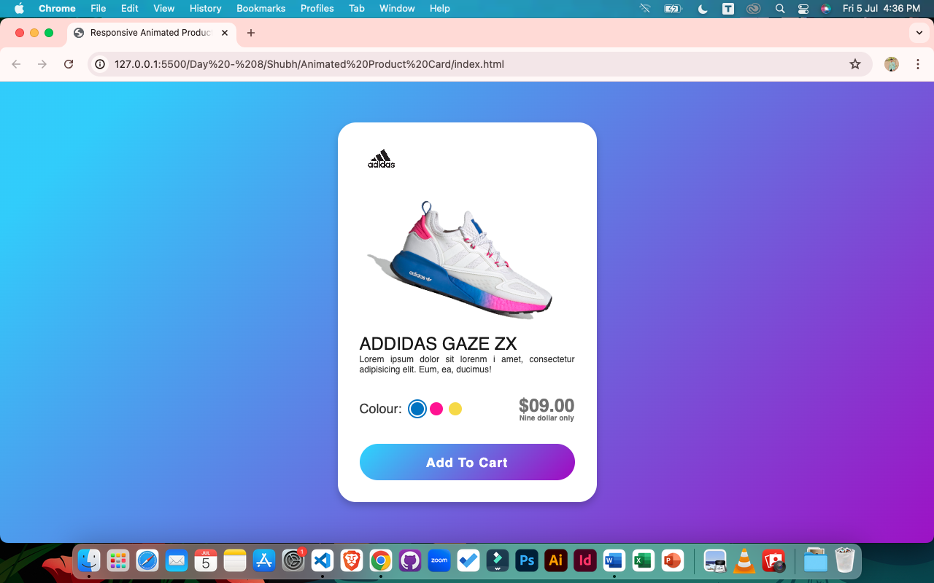

**Program – 2** : **Flipping Card UI Design**

**HTML :**

<!DOCTYPE html>

<html lang="en">

<head>

<meta charset="UTF-8" />

<meta http-equiv="X-UA-Compatible" content="IE=edge" />

<meta name="viewport" content="width=device-width, initial-scale=1.0" />

<title>Flipping Card UI Design</title>

<link rel="stylesheet" href="style.css" />

</head>

<body>

<section>

<div class="container">

<div class="card front-face">

<header>

<span class="logo">

<img src="images/logo.png" alt="" />

<h5>Master Card</h5>

</span>

<img src="images/chip.png" alt="" class="chip" />

</header>

<div class="card-details">

<div class="name-number">

<h6>Card Number</h6>

<h5 class="number">8050 2030 3020 5040</h5>

<h5 class="name">Soni Shubh Hiren</h5>

</div>

<div class="valid-date">

<h6>Valid Thru</h6>

<h5>05/28</h5>

</div>

</div>

</div>

<div class="card back-face">

<h6>

For customer service call +977 4343 3433 or email at

mastercard@gmail.com

</h6>

<span class="magnetic-strip"></span>

<div class="signature"><i>005</i></div>

<h5>

Lorem ipsum dolor sit amet, consectetur adipisicing elit. Officia

maiores sed doloremque nesciunt neque beatae voluptatibus doloribus.

Libero et quis magni magnam nihil temporibus? Facere consectetur

dolore reiciendis et veniam.

</h5>

</div>

</div>

</section>

</body>

</html>

**CSS :**

/* Import Google Font - Poppins */

@import url("https://fonts.googleapis.com/css2?family=Poppins:wght@300;400;500;600&display=swap");

* {

margin: 0;

padding: 0;

box-sizing: border-box;

font-family: "Poppins", sans-serif;

}

section {

position: relative;

min-height: 100vh;

width: 100%;

background: #121321;

display: flex;

align-items: center;

justify-content: center;

color: #fff;

perspective: 1000px;

}

section::before {

content: "";

position: absolute;

height: 240px;

width: 240px;

border-radius: 50%;

transform: translate(-150px, -100px);

background: linear-gradient(90deg, #9c27b0, #f3f5f5);

}

section::after {

content: "";

position: absolute;

height: 240px;

width: 240px;

border-radius: 50%;

transform: translate(150px, 100px);

background: linear-gradient(90deg, #9c27b0, #f3f5f5);

}

.container {

position: relative;

height: 225px;

width: 375px;

z-index: 100;

transition: 0.6s;

transform-style: preserve-3d;

}

.container:hover {

transform: rotateY(180deg);

}

.container .card {

position: absolute;

height: 100%;

width: 100%;

padding: 25px;

border-radius: 25px;

backdrop-filter: blur(25px);

background: rgba(255, 255, 255, 0.1);

box-shadow: 0 25px 45px rgba(0, 0, 0, 0.25);

border: 1px solid rgba(255, 255, 255, 0.1);

backface-visibility: hidden;

}

.front-face header,

.front-face .logo {

display: flex;

align-items: center;

}

.front-face header {

justify-content: space-between;

}

.front-face .logo img {

width: 48px;

margin-right: 10px;

}

h5 {

font-size: 16px;

font-weight: 400;

}

.front-face .chip {

width: 50px;

}

.front-face .card-details {

display: flex;

margin-top: 40px;

align-items: flex-end;

justify-content: space-between;

}

h6 {

font-size: 10px;

font-weight: 400;

}

h5.number {

font-size: 18px;

letter-spacing: 1px;

}

h5.name {

margin-top: 20px;

}

.card.back-face {

border: none;

padding: 15px 25px 25px 25px;

transform: rotateY(180deg);

}

.card.back-face h6 {

font-size: 8px;

}

.card.back-face .magnetic-strip {

position: absolute;

top: 40px;

left: 0;

height: 45px;

width: 100%;

background: #000;

}

.card.back-face .signature {

display: flex;

justify-content: flex-end;

align-items: center;

margin-top: 80px;

height: 40px;

width: 85%;

border-radius: 6px;

background: repeating-linear-gradient(

#fff,

#fff 3px,

#efefef 0px,

#efefef 9px

);

}

.signature i {

color: #000;

font-size: 12px;

padding: 4px 6px;

border-radius: 4px;

background-color: #fff;

margin-right: -30px;

z-index: -1;

}

.card.back-face h5 {

font-size: 8px;

margin-top: 15px;

}

**Output :**

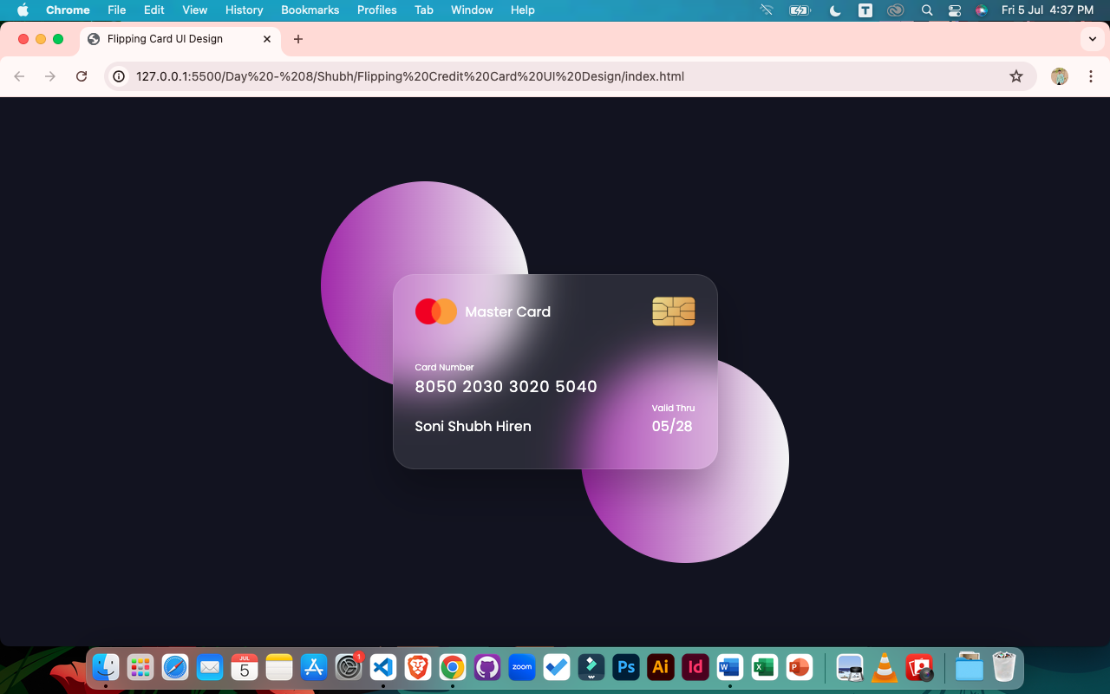

**Program – 3 : Profile Card UI Design**

**HTML :**

<!DOCTYPE html>

<html lang="en">

<head>

<meta charset="UTF-8">

<meta name="viewport" content="width=device-width, initial-scale=1.0">

<title>Profile Card UI Design</title>

<!-- CSS -->

<link rel="stylesheet" href="styles.css">

<!-- Boxicons CSS -->

<link href='https://unpkg.com/boxicons@2.1.4/css/boxicons.min.css' rel='stylesheet'>

</head>

<body>

<div class="profile-card">

<div class="image">

<img src="profile.jpg" alt="Shubh Soni's Image" class="profile-img">

</div>

<div class="text-data">

<span class="name">Shubh Soni</span>

<span class="job">Programmer & Developer</span>

</div>

<div class="media-buttons">

<a href="#" style="background: #4267b2;" class="link">

<i class='bx bxl-facebook'></i>

</a>

<a href="#" style="background: #1da1f2;" class="link">

<i class='bx bxl-twitter'></i>

</a>

<a href="#" style="background: #e1306c;" class="link">

<i class='bx bxl-instagram'></i>

</a>

<a href="#" style="background: #0e77ef;" class="link">

<i class='bx bxl-linkedin'></i>

</a>

</div>

<div class="buttons">

<button class="button">Subscribe</button>

<button class="button">Message</button>

</div>

<div class="analytics">

<div class="data">

<i class='bx bx-heart'></i>

<span class="number">60k</span>

</div>

<div class="data">

<i class='bx bx-message-rounded'></i>

<span class="number">20k</span>

</div>

<div class="data">

<i class='bx bx-share'></i>

<span class="number">12k</span>

</div>

</div>

</div>

</body>

</html>

**CSS :**

/* Google Fonts - Poppins */

@import url('https://fonts.googleapis.com/css2?family=Poppins:wght@300;400;500;600&display=swap');

*{

margin: 0px;

padding: 0px;

box-sizing: border-box;

font-family: 'Poppins', san;

}

body{

height: 100vh;

display: flex;

align-items: center;

justify-content: center;

background-color: #f4f4f4;

}

.profile-card{

display: flex;

flex-direction: column;

align-items: center;

max-width: 370px;

width: 100%;

background: #fff;

border-radius: 24px;

padding: 25px;

box-shadow: 0 5px 10px rgba(0, 0, 0, 0.4);

position: relative;

}

.profile-card::before{

content: '';

position: absolute;

top: 0;

left: 0;

height: 36%;

width: 100%;

background-color: #4070f4;

border-radius: 24px 24px 0 0;

}

.image{

position: relative;

height: 150px;

width: 150px;

border-radius: 50%;

background-color: #4070f4;

padding: 3px;

margin-bottom: 10px;

}

.image .profile-img{

height: 100%;

width: 100%;

object-fit: cover;

border-radius: 50%;

border: 3px solid #fff;

}

.profile-card .text-data{

display: flex;

flex-direction: column;

align-items: center;

}

.text-data .name{

font-size: 22px;

font-weight: 500;

}

.text-data .job{

font-size: 15px;

font-weight: 400;

}

.profile-card .media-buttons{

display: flex;

align-items: center;

margin-top: 15px;

}

.media-buttons .link{

display: flex;

align-items: center;

justify-content: center;

color: #fff;

font-size: 18px;

height: 34px;

width: 34px;

margin: 0 8px;

border-radius: 50%;

background-color: #4070f4;

text-decoration: none;

}

.profile-card .buttons{

display: flex;

align-items: center;

margin-top: 25px;

}

.buttons .button{

color: #fff;

font-size: 14px;

font-weight: 400;

border: none;

border-radius: 24px;

margin: 0 10px;

padding: 8px 24px;

background-color: #4070f4;

cursor: pointer;

transition: all 0.3s ease;

}

.buttons .button:hover{

background-color: #0e4bf1;

}

.profile-card .analytics{

display: flex;

align-items: center;

margin-top: 25px;

}

.analytics .data{

display: flex;

align-items: center;

color: #333;

padding: 0 20px;

border-right: 2px solid #e7e7e7;

cursor: pointer;

}

.data i{

font-size: 18px;

margin-right: 6px;

}

.data:last-child{

border-right: none;

}

**Output :**

